CST 229 – Lecture 8
Wilsonville, Fall 2017

Ch 21-22: Variations on TMs

2PDA – Two-Stack PDA (pg. 480)
Two stacks, PUSH and POP states indicate which stack to use, always deterministic

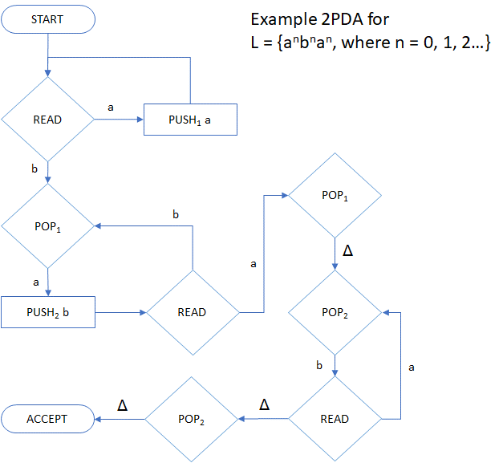

Theorem 50 (Marvin Minsky, 1961)
2PDA = TM

Minsky proved that for any 2PDA, you can construct an equivalent TM and, for any TM, you can construct an equivalent 2PDA

What about 3, 4 or more stacks?

Theorem 51
nPDA = TM, for n >= 2

Turns out that adding more stacks does not make a PDA more powerful, beyond 2
They’ll be faster! And easier to “program”, but not more powerful.

Move-In-State Machine (pg. 494)
Looks like a combo Mealy / Moore / TM …
Transitions show which character to read and write
States show which direction to move the the tape head when state is entered

In the example below
“1 / R” is state 1, and the tape head moves Right when the machine enters state 1
If it reads an ‘a’, it writes ‘x’ and then transitions to state 2

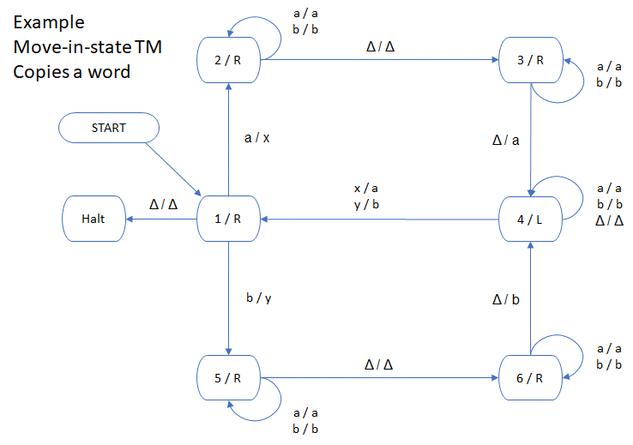

Theorem 53
Move-in-state Machines = TM

Not only will they accept the same languages, they can be constructed to leave the tape in exactly the same state, with letters and blanks in the same positions

Stay-Option Machine (pg. 499)
Enhanced TM with the choice to not move the tape on a transition
Transitions can include “S” (stay) for tape direction, as well as “L” and “R”

For example, when we want to go back left down the tape, looking for a special symbol, like ‘*’, and then leave the tape head pointing at the ‘*’, we have to write something like this…
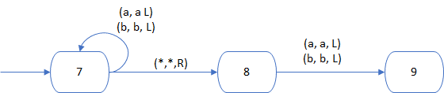

With the Stay-Option Machine, we can instead simplify and write this..
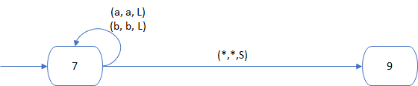

Theorem 54
Stay-Option Machine = TM

Think of a TM as a type of Stay-Option Machine where we don’t use the stay option
Then, definitely we can construct Stay-Option Machines from an TM

But why aren’t Stay-Option Machines stronger than TMs?
Turns out that it just takes one more state in a TM to simulate the Stay option
Replace a the Stay in the first diagram below, with the new state in the second diagram…

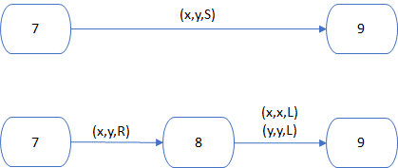

Interestingly, the Stay-Option Machine is more efficient to program and run, but not more powerful than a regular TM

Is a trend emerging here?

k-Track Machine (pg. 502)
A TM with k parallel tapes, k > 1, but still one tape head, called a kTM
Transitions include values for each tape in the read/write
The head moves Left or Right along all tapes in parallel

The following example performs binary addition
It assumes that there are $ at the left of each tape
The two numbers to be added are loaded in tape 1 and tape 2
The result is read out of tape 2

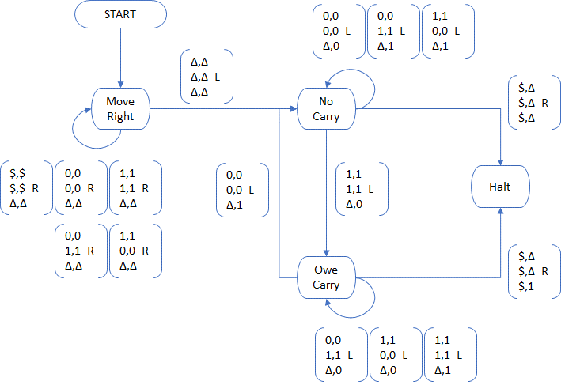
Theorem 55
kTM = TM

The proof is fairly invovled, but basically, it demonstrates that we can think of the various tracks as just different sections of the same infinite TM tape
It will just require more states in a TM to move the head back and forth

This means that the kTM is faster, but actually not more powerful

Two-Way Infinite Tape Machine (pg. 511)
A TM where the tape continues infinitely in both directions
The input string is encoded starting at the initial location, going to the right

This was actually Turing’s original idea
Today we call this the Two-way Infinite Tape TM
The one we’ve been studying so far a One-way Infinite Tape TM (or just TM)

Theorem 56
Two-way Infinite Tape TMs = One-way Infinite Tape TMs

How?
That’s easy… just fold the tape over and make a 2TM out of it!
And 2TM = TM… q.e.d

Again, this equivalence is in terms of power…
We can construct machines on one side that accpet exactly the language for a machine on the other side

And again, we will need fewer states for a Two-way TM… they’re faster!

When does this stop?
Alright, you say! We get it!

We can stop here! What about…

One tape, multiple tape heads? = TM
Many tapes and many heads? = TM
Two-dimensional tape with one head? = TM
Two-dimensional tape and many heads? = TM

All equivalent to TMs… provably so
They will be more efficient to program, faster to run
But will accept the same languages

Wait! Remember the PDA and NPDA?
We found that for accepting all CFLs, we needed to go Non-deterministic
How about Non-determinsitic TMs?
Surely those are more powerful…

Non-Deterministic TM (pg. 518)
An NTM is a TM that may have multiple transitions out of a state for same input letter
A string is accepted if there exists any path to a Halt state

That’s got to be more powerful… right?

Theorem 57
NTM = TM

How is this possible?

We can construct a deterministic TM that “explores” the possible paths and ultimately chooses the one that accepts the string.

For example, use a 3-Track TM (a 3TM), like so…
Track 1: Input and results of current experiment
Track 2: Sequence of state transitions to try
Track 3: Original input string (used to reset Track 1, when ready to try next path)

This means that if there is an NTM that accepts a language, then we can construct a larger, but equivalent 3TM that simulates its behavior

Wow.

While we’re here, note that we’ve just made it possible to prove…

Theorem 58
Every CFL can be accepted by some TM

Why?

Because some CFLs requires an NPDA, and we can easily construct an NTM that is equivalent to an NPDA… and now we know that NTM = TM

Oh wait, there’s a little more to say about TM variations…

Read-Only TM (pg. 524)
A TM where the tape head cannot write to the tape

Theorem 59
Read-Only TM = FA

They only accept Regular Languages.

